:ETABle Commands

The :ETABle commands are used to set the parameters related to the decoding event table.

Command List:
- :ETABle<n>:DISP
- :ETABle<n>:FORMat
- :ETABle<n>:VIEW
- :ETABle<n>:COLumn
- :ETABle<n>:ROW
- :ETABle<n>:SORT
- :ETABle<n>:DATA?

:ETABle<n>:DISP
Syntax | :ETABle<n>:DISP <bool>  :ETABle<n>:DISP?
Description | Turn on or off the decoding event table, or query the status of the decoding event table.
Parameter | Name | Type | Range | Default
 | <n> | Discrete | {1|2} | --
 | <bool> | Bool | {{1|ON}|{0|OFF}} | 0|OFF
Explanation | This command is only valid when the decoder is turned on (:DECoder<n>:DISPlay).
Return format | The query returns 1 or 0.
Example | :ETABle1:DISP ON /*Turn on the decoding event table*/  :ETABle1:DISP? /*The query returns 1*/

:ETABle<n>:FORMat
Syntax | :ETABle<n>:FORMat <fmt>  :ETABle<n>:FORMat?
Description | Set or query the data display format of the event table.
Parameter | Name | Type | Range | Default
 | <n> | Discrete | {1|2} | --
 | <fmt> | Discrete | {HEX|ASCii|DEC} | HEX
Return format | The query returns HEX, ASC or DEC.
Example | :ETABle1:FORMat ASCii /*Set the data display format of the event table to ASCII*/  :ETABle1:FORMat? /*The query returns ASC*/

:ETABle<n>:VIEW
Syntax | :ETABle<n>:VIEW <view>  :ETABle<n>:VIEW?
Description | Set or query the display mode of the event table.
Parameter | Name | Type | Range | Default
 | <n> | Discrete | {1|2} | --
 | <view> | Discrete | {PACKage|DETail|PAYLoad} | PACKage
Explanation | - PACKage: the time and data are displayed in the event table.  - DETail: the detailed data of the specified row is displayed in the event table.  - PAYLoad: all data of the specified column is displayed in the event table.
Return format | The query returns PACK, DET or PAYL.
Example | :ETABle1:VIEW PAYLoad /*Set the display mode of the event table to PAYLoad*/  :ETABle1:VIEW? /*The query returns PAYL*/

:ETABle<n>:COLumn
Syntax | :ETABle<n>:COLumn <col>  :ETABle<n>:COLumn?
Description | Set or query the current column of the event table.
Parameter | Name | Type | Range | Default
 | <n> | Discrete | {1|2} | --
 | <col> | Discrete | {DATA|TX|RX|MISO|MOSI} | --
Explanation | When different decoder is selected (:DECoder<n>:MODE), the range of <col> differs.  - Parallel decoding: DATA  - RS232 decoding: TX|RX  - I2C decoding: DATA  - SPI decoding: MISO|MOSI  - If the TX or RX channel source in RS232 decoding or the MISO or MOSI channel source in SPI decoding is set to OFF, <col> cannot be set to the corresponding parameter.
Return format | The query returns DATA, TX, RX, MISO or MOSI.
Example | :ETABle1:COLumn DATA /*Set the current column to DATA*/  :ETABle1:COLumn? /*The query returns DATA*/
Related commands | :DECoder<n>:UART:TX  :DECoder<n>:UART:RX  :DECoder<n>:SPI:MISO  :DECoder<n>:SPI:MOSI

:ETABle<n>:ROW
Syntax | :ETABle<n>:ROW <row>  :ETABle<n>:ROW?
Description | Set or query the current row of the event table.
Parameter | Name | Type | Range | Default
 | <n> | Discrete | {1|2} | --
 | <row> | Integer | 1 to the maximum number of rows of the current event table | 1
Return format | The query returns the current row in integer. If the current even table is empty, the query returns 0.
Example | :ETABle1:ROW 2 /*Set the current row to 2*/  :ETABle1:ROW? /*The query returns 2*/

:ETABle<n>:SORT
Syntax | :ETABle<n>:SORT <sort>  :ETABle<n>:SORT?
Description | Set or query the display type of the decoding results in the event table.
Parameter | Name | Type | Range | Default
 | <n> | Discrete | {1|2} | --
 | <sort> | Discrete | {ASCend|DESCend} | ASCend
Explanation | - ASCend: the events are displayed in the order in which they occurred.  - DESCend: the events are displayed in the order reverse to the order in which they occurred.
Return format | The query returns ASC or DESC.
Example | :ETABle1:SORT DESCend /*Set the display type of the event table to descend*/  :ETABle1:SORT? /*The query returns DESC*/

:ETABle<n>:DATA?
Syntax | :ETABle<n>:DATA?
Description | Read the current event table data.
Parameter | Name | Type | Range | Default
 | <n> | Discrete | {1|2} | --
Return format | The query returns the event table data in the format as shown in the figure below.  Wherein, #9000000098 is the TMC data description header followed by the even table data and its format is #900000dddd. dddd denotes the number of bytes of the valid waveform data following the description header. For example, as shown in the figure below, #9000000098 is the TMC data description header, wherein, 98 denotes that there are 98 bytes of valid data. The content following 98 is the event table data.  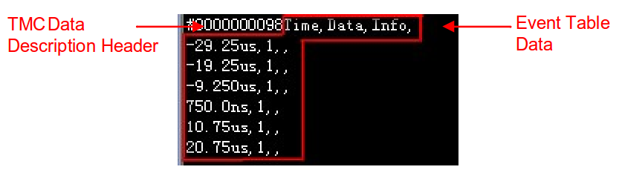
Example | :ETABle1:DATA? /*The query returns the data as shown in the figure above*/

